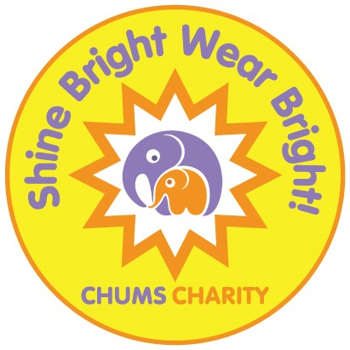
3 children in every classroom have a diagnosable mental health disorder

Only 1 of them currently receives support.

Who decides which two won’t?

You can help CHUMS to change this so that children who need support CAN access it.

SHINE BRIGHT, WEAR BRIGHT during Children’s Mental Health Week
4th – 10th February 2019.

In 2018 many schools, nurseries and organisations across Bedfordshire took part in SHINE BRIGHT, WEAR BRIGHT by encouraging children and young people to talk about mental health, being kind and being ourselves, ending the week with a non-uniform ‘wear bright’ day with students donating £1 to CHUMS.

Schools, nurseries and organisations took part in other fundraising activities such as a sponsored silence, cake sale, sponsored football event and celebration assemblies. Harrold Primary School raised over £1,000 during Mental Health Week 2018 for CHUMS!

In 2019 we are asking everyone to take part in SHINE BRIGHT, WEAR BRIGHT and fundraise vital funds for CHUMS and talk about mental health. CHUMS will also offer downloadable activity and information sheets that you can use in the classrooms and assemblies.

Do you have a PTA in your school or a group of willing students? Would they be interested in arranging a SHINE BRIGHT TALENT SHOW? Potentially splitting profits from the tickets sold between CHUMS and your school/PTA?

A talent show is great way to showcase individual or group talents by hosting an evening show. You may also wish to run an art and poem display of talents in the refreshment area during the interval. The Talent Show could be as big or as little as you want it to be – you could decide to merge with another local school?

CHUMS has been supporting children and young people for 21 years. In our first year we helped 40; in 2018 it will be more than 5,000!

We are proud and thrilled to have been helping children and young people with their mental health and wellbeing since 1997 but to continue some of our services we need support from the local community.

CHUMS Charity services include:
- Babyloss Service
- Bedfordshire Suicide Bereavement Service
- Disability Friendship Scheme
- Recreational Therapy (therapy through music or football programmes)
- Trauma (bereavement and non-bereavement)

If you would like to register your interest in SHINE BRIGHT, WEAR BRIGHT - the week before half term during Mental Health Week 2019 (or a day of your choice) please contact Corporate and Community Fundraising Manager Hannah Chard at: hannah.chard@chumscharity.org , ring 01525 863924 or return the slip below.

CHUMS will provide posters for SHINE BRIGHT, WEAR BRIGHT 2019 and the SHINE BRIGHT TALENT SHOW plus letters to send home to parents and information and workshop activity sheets. These will be on our website to download towards the end of the year.

Kind regards

Hannah Chard

Corporate and Community Fundraising Manager

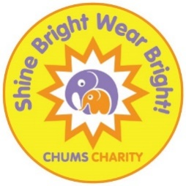

We are interested in taking part in SHINE BRIGHT, WEAR BRIGHT 2019

Contact Name:

Contact Email:

School Name and Address:

Comments:

Please return this slip to Fundraising Team, CHUMS, Wrest Park, Enterprise House, Silsoe, Beds, MK45 4HS or email the details to hannah.chard@chumscharity.org

Thank you

