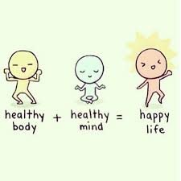

1. Prior to the lesson, label a jar (such as a mason jar or big jam jar) as the ‘Class Healthy Inside and Out Jar’. Also, collect some pebbles and cotton wool.
2. For each act of physical activity a member of the class completes or sees another student do, they can place a piece of cotton wool in the jar (you can supplement for another small item).
3. For each act of kindness, students can add a pebble to the jar. Explain that being kind to other people impacts on their mental health therefore it’s important to be kind to keep healthy on the inside.
4. At the end of the week the pebbles can transform into sweets/chocolates for the class to share!
5. Some examples of kind things they can do include: helping to tidy up whilst hopping on one leg, playing with someone different, helping the teacher and giving someone a compliment.

Class Healthy Inside and Out Jar

Teachers Instructions