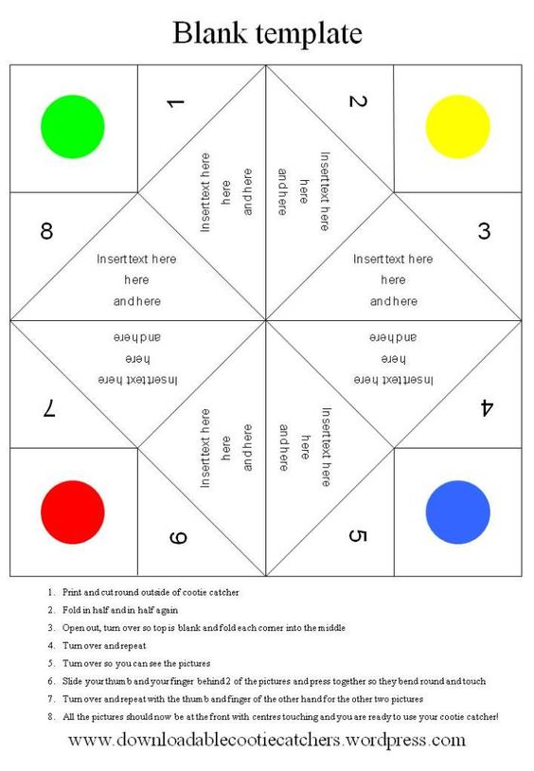

The Healthy Catchers –

Teachers Instructions



1. Using the template provided, ask children to cut out the healthy catcher and think of images relating to healthy minds and bodies to put in the gaps i.e. eating something healthy or doing some exercises.
2. Ask the children to colour and decorate the healthy catcher to make it extra special.
3. Fold in half and in half again, open out and turn over, fold each corner into the middle, turn over and repeat, turn over and slide your fingers behind two of the colours and bend round so they touch, repeat for the other two colours.
4. The healthy catcher works using the following instructions:
   1. Ask a friend to choose a colour
   2. Ask your friend to choose one of the numbers that appears when you open that colour
   3. Count side to side and up and down to the correct number
   4. Choose a new number and open the flap
   5. The friend now has to complete that act of healthy activity.
5. The children can play with their healthy catchers in class and in the playground.

**Please follow this**

**guide when asking**

**children to complete**

**their kindness**

**catcher**