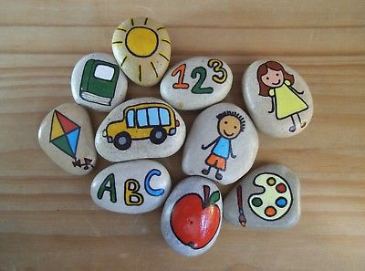

‘First, I eat healthy; it comes from the inside out. If you eat right, your skin, hair and nails will look good. The same if you have negative thoughts – they can give you a bad look too; we reflect what we eat and think. We also taste and smell what we eat. Being happy and doing what I love really reflects.’

Kate Del Castillo

Healthy Pebbles -

Teachers Instructions

1. Prior to the class starting, please gather large pebbles and paints for this activity.
2. Ask the students to choose a pebble and write their first name and school on the back.
3. Encourage the children to paint the pebbles with healthy foods, activities or encouraging words.
4. Once the pebbles have dried, get the children to hide them anywhere locally.
5. The idea of this activity is for people to find the pebbles and re hide them. Look online to see if your local area has a ‘rocks’ page and promote or monitor on there.