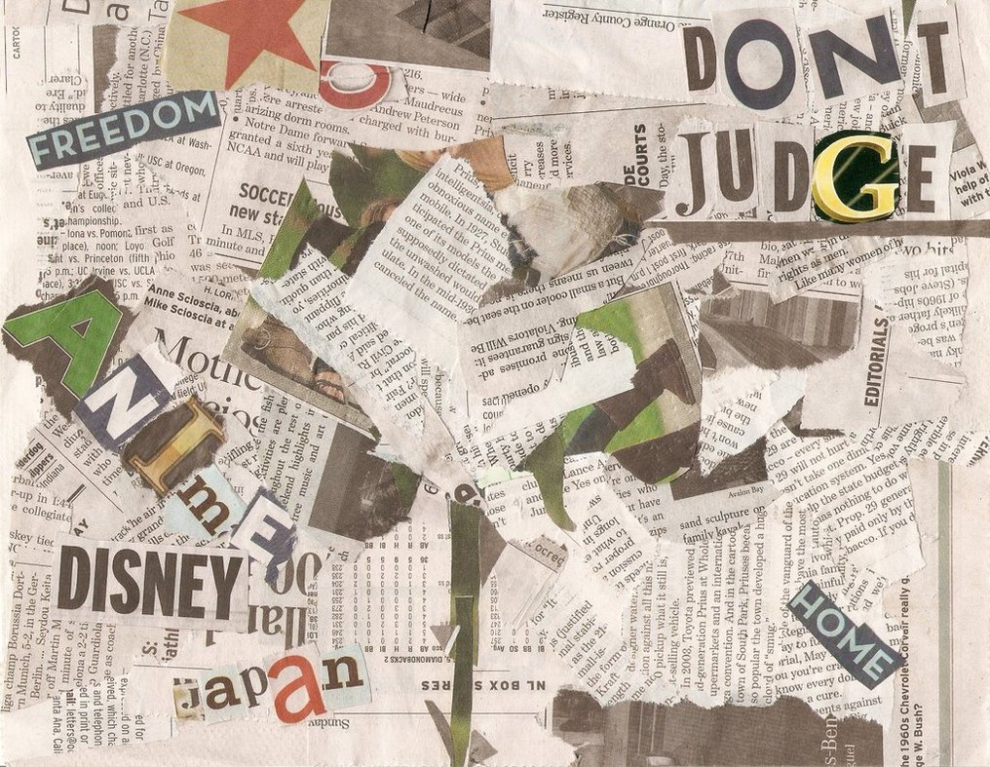

1. Collect together a range of newspapers and magazines that students can cut out
2. Give each student a piece of A4 or A3 piece of paper
3. Ask them to cut out words and pictures from the newspapers and magazines that relating how they keep themselves healthy inside and out – these could be words that describe them such as ‘athletic’ or ‘healthy eater’ etc. They could also include pictures like footballs for hobbies and swimming for their likes and interests.
4. When everyone has completed theirs, share them amongst the class and see how everyone has different words and pictures which are compiled differently, so we are unique in lots of different ways.

Unique Collage –

Teachers Instructions