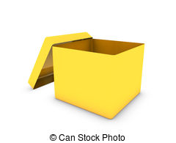

1. As a class, decorate a cardboard box with yellow pictures/paper/stickers etc.
2. On yellow bits of paper ask each student to write down something kind, draw a nice picture which can be placed inside the box
3. At the end of the week swap your ‘box of happiness’ with another class who have taken part in the activity and as a class have a look at all the nice things that are inside the box
4. These things should make the class feel happy and that kindness and happiness can be shared – the idea that if someone does something nice for you, you should do something nice in return
5. Some ideas include; a picture of a sunshine, ‘I like when we get to play with your class’, ‘Student A was nice to me when I fell over’ etc.

We are sending you a Box of Happiness to brighten up your day, sometimes this is all you need to make you feel less grey.

Box of Happiness –

Teachers Instructions