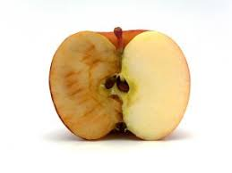

The Good Apple, Bad Apple experiment

Teachers Instructions

1. Prior to the class, label two glass jars with ‘Good’ and ‘Bad’
2. In the class explain how this is an ordinary apple and then cut the apple in half.
3. Put one half into the jar labelled ‘good’ and the other half into the jar labelled ‘bad’.
4. Split the children into two groups. Get one group to say nice words to the apple in the ‘good’ jar and the other group to say bad words to the apple in the ‘bad’ jar. Let the children speak to both.
5. Close the lid on both jars and place them both somewhere the children can see.
6. Repeat this daily for five days.
7. At the end of the five days the class will see the difference in colour of the two halves of apples. The ‘bad’ apple will be discoloured and mouldy. The ‘good’ apple will be less discoloured.
8. The idea of the experiment is for children to see the negative effect bad words have on people’s emotional and mental health and wellbeing.

Follow this link to watch a video of the experiment: https://www.youtube.com/watch?v=3UGhb1OI174