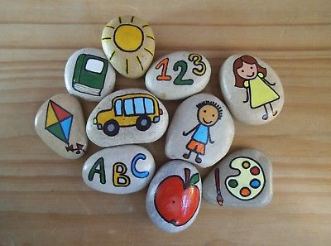

‘The thing about bravery is it doesn’t come with the absence of fear and hurt. Bravery is the ability to look fear and hurt in the face and say move aside, you’re in my way.’

Melissa Tumino

Braveness Pebbles -

Teachers Instructions

1. Prior to the class starting, please gather large pebbles and paints for this activity.
2. Ask the students to choose a pebble and write their first name and school on the back.
3. Encourage the children to paint the pebbles with things that make them feel brave, activities or encouraging words.
4. Once the pebbles have dried, get the children to hide them anywhere locally.
5. The idea of this activity is for people to find the pebbles and re hide them. Look online to see if your local area has a ‘rocks’ page and promote or monitor on there.