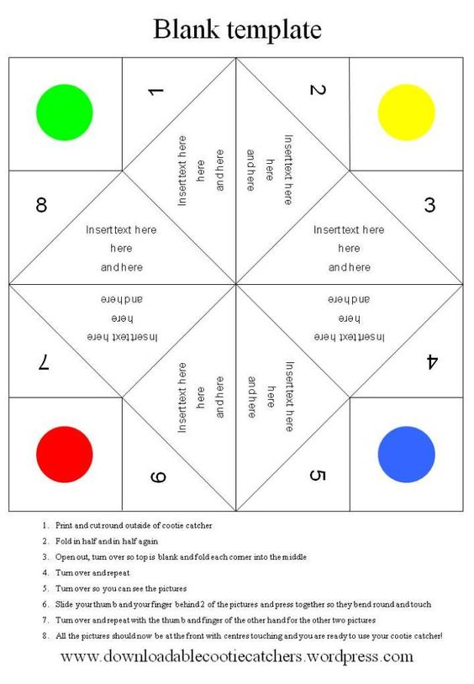

The Emotion Catchers –

Teachers Instructions



1. Using the template provided, ask children to cut out the emotion catchers and think of images relating to emotions to put in the gaps i.e. anxious, worried or happy.
2. Ask the children to colour and decorate the emotion catcher to make it extra special. On the spaces inside ask the children to write an emotional or feeling on each one.
3. Fold in half and in half again, open out and turn over, fold each corner into the middle, turn over and repeat, turn over and slide your fingers behind two of the colours and bend round so they touch, repeat for the other two colours.
4. The emotion catcher works using the following instructions:
   1. Ask a friend or family member to choose a colour
   2. Ask your friend or family member to choose one of the numbers that appears when you open that colour
   3. Count side to side and up and down to the correct number
   4. Choose a new number and open the flap
   5. The friend or family member must now show how they would express this emotion.
5. The children can play with their emotion catchers in class and in the playground.

**Please follow this**

**guide when asking**

**children to complete**

**their braveness**

**catcher**