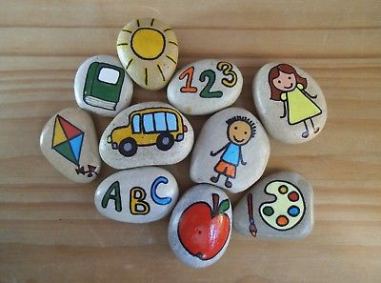

‘Live life as though nobody is watching, and express yourself as though everyone is listening’

Nelson Mandela

Emotion Pebbles -

Teachers Instructions

1. Prior to the class starting, please gather large pebbles and paints for this activity.
2. Ask the students to choose a pebble and write their first name and school on the back.
3. Encourage the children to paint the pebbles with an emotion they are feeling, activities or encouraging words.
4. Once the pebbles have dried, get the children to hide them anywhere locally.
5. The idea of this activity is for people to find the pebbles and re hide them. Look online to see if your local area has a ‘rocks’ page and promote or monitor on there.