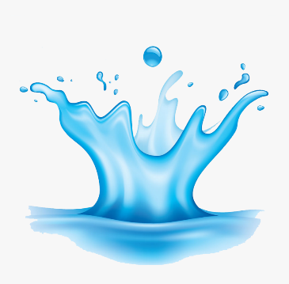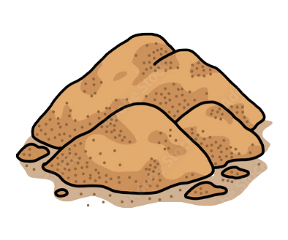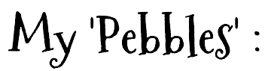

D

D

D

D

*Why is my ‘Water’ important to me?*

D

D

D

D

D

*Why is my ‘Sand’ important to me?*

D

D

D

D

D

*Why are my ‘Pebbles’ important to me?*

*Why are my ‘Big Rocks’ important to me?*

D

D

D

D

D

D