We are all a little bit like a rose. We have good parts about us just like the rose itself. We have some areas that are a bit challenging, just like the thorns and we are learning and growing just like the bud.

|  |  |
| --- | --- |
| rose PNG655 | This activity involves you reflecting on your rose, buds and thorns.  Mountains of Christmas Regular  Talk to someone about something positive that has happened to you, something you have achieved or something you have overcome. |
| Red Rose Bud&quot; Poster by msfirmamat | Redbubble | Mountains of Christmas Regular  Use the space below to draw out your exciting new ideas, the things you are looking forward to or your hopes for the future. |
| Get Notified Of Exclusive Freebies - Rose With Thorn Clipart (640x1280) | Mountains of Christmas Regular  Write down a challenge that you are facing, something you need a bit of support with or something that is making you sad. |



Have a look at the worksheet next to you. What’s the same and what’s different?



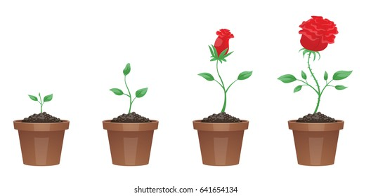

Ideas from: www.mindfulschools.org



* Just like roses we all have our differences!
* Sometimes roses have lots of thorns whilst others have lots of buds. They all grow differently just like us!
* It’s important to talk to those around you about your rose, buds and thorns